

Compensation and Pension Record Interchange (CAPRI)

(CAPRI GUI v. DVBA_27_149_11)

Release Notes

Patch DVBA*2.7*149

March 2011

Department of Veterans Affairs
Office of Enterprise Development
Management & Financial Systems

Preface
Purpose of the Release Notes
The Release Notes document describes the new features and functionality of Patch DVBA*2.7*149.
Reference Numbering System
This document uses a numbering system to organize its topics into sections and show the reader how these topics relate to each other. For example, section 1.3 means this is the main topic for the third section of Chapter 1. If there were two subsections to this topic, they would be numbered 1.3.1 and 1.3.2. A section numbered 2.3.5.4.7 would be the seventh subsection of the fourth subsection of the fifth subsection of the third topic of Chapter 2. This numbering system tool allows the reader to more easily follow the logic of sections that contain several subsections.

Table of Contents
1. Overview 1
2. Customer – Veteran’s Health Administration (VHA) 1
2.1 Defect Fixes 1
2.1.1. Defect Fixes with Remedy Tickets 1
2.1.1.1. HD0000000360917- ~close~ 1
2.1.1.2. HD0000000408062:Default on save 2
2.1.2. Defect Fixes with CearQuest Tickets 2
2.1.2.1. CAPRI_CodeCR50:CAPRI - Enter New Patient screen SSN field disappears when duplicate Pseudo SSN 2
2.1.2.2. CAPRI_CodeCR105:An error may occur when saving a template more then once 2
2.1.2.3. CAPRI_CodeCR106:DENVER Reports - When previewing a report and autosave kicks off the cursor gets forced to the top of the report 3
2.1.2.4. CAPRI_CodeCR108:Reported by SAGINAW -During Co-signature process the template list is displaying the incorrect templates for signature 3
2.1.2.5. CAPRI_CodeCR112:Duplicate addendum appears in Clin Docs|Notes) 3
2.2 Enhancements 3
2.2.1. Enhancements with ClearQuest Tickets 3
2.2.1.1. CAPRI_CodeCR132:Don't allow future appointments to be selected 4
3. Customer – Veterans Benefits Administration (VBA) 4
3.1 Defect Fixes 4
3.1.1. Defect Fixes with Remedy Tickets 4
3.1.1.1. HD0000000321303:CAPRI can't specify printer tray; always prints to tray specified in default settings. 4
3.1.1.2. HD0000000363878:CAPRI time-out when cancelling "switch sites" from File menu. 4
3.1.1.3. HD0000000380184:Denver RO (339) CAPRI User, Gregg Linnert, reports CAPRI locking up when attempting to run CAPRI exam report for Cheyenne. 5
3.1.1.4. HD0000000392970:Waco users receive error "VABAB DATETIME could not be accessed" when printing C&P Exams 5
3.1.2. Defect Fixes with CearQuest Tickets 5
3.1.2.1. CAPRI_CodeCR84:VBA - St. Petersburg users have reported that Capri is not duplexing while printing. 5
3.1.2.2. CAPRI_CodeCR85:VBA - 143.10 Secondary Monitor - application exception error - Range check error 5
3.1.2.3. CAPRI_CodeCR71:Typographical error in the message I received when trying to click “Cancel ALL Exams” 6
3.1.2.4. CAPRI_CodeCR73:The scroll bar on the “County” drop down list (Address Verification Screen accessible from “Add a New C&P Exam Request”) is hidden. 6
3.1.2.5. CAPRI_CodeCR89:Get error(s) when click on Status Inquiry when a C&P Exam request is in "Transferred Out" status 6
3.1.2.6. CAPRI_CodeCR102:DOD tab date dropdowns are cutoff when CAPRI is full screen 7
3.1.2.7. CAPRI_CodeCR147:Insufficient Exam report dialog box fails to display or pass Reason field to RPC 7
3.1.2.8. CAPRI_CodeCR156:Update C&P Training website URL 7
3.1.2.9. CAPRI_CodeCR160: Last Entry Service Date does not Appear on C&P Exam Detail 7
3.2 Enhancements 9
3.2.1. Enhancements with ClearQuest Tickets 9
3.2.1.1. CAPRI_CodeCR123:New Priority of Exam(s) Types 9
3.2.1.1. CAPRI_CodeCR124:Make Fee Basis Community Nursing Home (FBCNH) Reports Available in CAPRI 11
3.2.1.2. CAPRI_CodeCR126:Modify CAPRI to Allow Users to Select More Than One Outpatient Report to View When Using ‘Report Builder’ 12
3.2.1.3. CAPRI_CodeCR127:Display the Date Range at the Top of the Special Report for Pension / Aid and Attendance 12
3.2.1.4. CAPRI_CodeCR129:Ability to Download Hospital Adjustment Reports into Excel/Access 12
3.2.1.1. CAPRI_CodeCR130:Printing CAPRI Reports larger than 50 pages 27
3.2.1.2. CAPRI_CodeCR136:AMIE: Modify DVBA C ENTER C&P REQUEST to display foreign address 28
3.2.1.3. CAPRI_CodeCR153:Remove Direct Appointment Global Reference 28
3.2.1.4. CAPRI_CodeCR158:Add New Cancellation Reason to 2507 CANCELLATION REASON File #396.5 28
3.2.1.5. CAPRI_CodeCR169: Enable the display of regional office substations in the Site List. 29
4. Customer – Health Revenue Center (HRC) Office 29
4.1 Defect Fixes 29
4.1.1. Defect Fixes with Remedy Tickets 29
4.1.1.1. HD0000000433116:HRC Users getting only Toolbox Menu 29
4.1.2. Defect Fixes with CearQuest Tickets 29
4.1.2.1. CAPRI_CodeCR104:Errors occur when user clicks more than once (double-click or more) on VistA button 29
4.2 Enhancements 30
4.2.1. Enhancements with ClearQuest Tickets 30
4.2.1.1. CAPRI_CodeCR109:HRC - Modify CAPRI GUI to Recognize New Menus Added in Patch 148 as Primary Menus 30
5. Customers – VBA and HRC 30
5.1 Defect Fixes 30
5.1.1. Defect Fixes with CearQuest Tickets 30
5.1.1.1. CAPRI_CodeCR77:143.10 CAPRI Remote Screen can no longer type site name with space and get to that site 31
5.2 Enhancements 31
5.2.1. Enhancements with ClearQuest Tickets 31
5.2.1.1. CAPRI_CodeCR:110 Display of VAMC Location City and State 31
6. Customer – Health Information Access (HIA) Office 31
6.1 Enhancements 31
6.1.1. Enhancements with ClearQuest Tickets 31
6.1.1.1. CAPRI_CodeCR131:HIA – Automating DoD Access Limitations 32
6.1.1.2. CAPRI_CodeCR161 – Modify HIA User Message Text for Patch Update 32
6.1.2. Enhancements That Did Not Require Source Code Changes 33
6.1.2.1. Removal of Simple Patient Entry Capability 33
7. Customer – Section 508 Compliance Office 33
7.1 Defect Fixes 33
7.1.1. Defect Fixes with CearQuest Tickets 33
7.1.1.1. 508 Non-Compliance Issues 33
8. Customer – All: General Modifications to CAPRI to Support all Customers 34
8.1 Enhancements 34
8.1.1. Enhancements with ClearQuest Tickets 34
8.1.1.1. CAPRI_CodeCR150:Add support for new Military Service Episode multiple field 34
9. Known Anomalies 34
9.1 CAPRI_CodeCR183: CAPRI 149 Military Service Episode Error 34
9.1.1. Issue: 34
9.1.2. Risk/Impact: 34
9.1.3. Workaround: 35
9.1.4. Comments: 35
10. CAPRI GUI v149 Upgrade Note 35
10.1. Backwards Compatibility Issue 35
10.2. McAfee Host Intrusion Prevention (HIPS) Configuration 35
11. Software and Documentation Retrieval 36
11.1 VistA Patch DVBA*2.7*149 36
11.2 CAPRI GUI v149 Client Software & User Documentation 36

Overview
The main purpose of this patch is to release a new version of the Compensation & Pension Record Interchange (CAPRI) Graphical User Interface (GUI) that includes defect fixes and enhancements to the user interface and VistA server modifications to support user interface modifications.
CAPRI GUI v149 and patch (DVBA*2.7*149) provide defect fixes and enhancements for the CAPRI GUI and the Automated Medical Information Exchange (AMIE) package.
The information contained in this document is not intended to replace the CAPRI User Manual. The software defects and enhancements are briefly discussed so that readers are aware of high level functional changes. The CAPRI User Manual should be used to obtain detailed information regarding specific functionality.

Customer – Veteran’s Health Administration (VHA)

Defect Fixes
The following section is an overview of the defects reported by the VHA that have been addressed and corrected in the CAPRI GUI v149 and VistA patch (DVBA*2.7*149) release.

Defect Fixes with Remedy Tickets
The following Patch DVBA*2.7*149 VHA reported defects have been documented in the BMC Software Inc.® Remedy Action Request (AR) System® Change Management tool.

HD0000000360917- ~close~
Duplicates: HD0000000367010 - 756- The template name changed when provider close template and is unable to open template.

HD0000000374387 - ~close~!
Issue
When a provider closes a template, it will occasionally be saved with the name ~CLOSE~. The user will be unable to re-open the template until the FORM TITLE field of the CAPRI TEMPLATES file entry for the form is changed to the correct form title using FileMan.
Solution
The file name was being used as a flag to indicate the current action. In some cases, it was not being restored to the correct file name. The code was modified to no longer use the file name as a flag. Templates will no longer be renamed as "~CLOSE~", or require renaming of the CAPRI TEMPLATES entry to be reopened.

HD0000000408062:Default on save
Duplicates: HD0000000413469: CAPRI closes Expanded Details window without warning.
HD0000000432520:Save option on worksheet defaults to NO.

HD0000000444090: CAPRI closes Details Window without warning.
Issue

When editing a template, if one is editing expanded details when an autosave kicks off, it will pop up a dialog that asks the user if they want to close without saving. "Yes" is the default button, and this will cause text entered into the memo not to be saved. So if a user does not see the dialog while trying to type in the memo then presses the space bar, this will trigger the default behavior and cause the entered data to be lost.
Solution
The save logic and interface have been changed to eliminate this problem.

Defect Fixes with CearQuest Tickets
The following Patch DVBA*2.7*149 VHA reported defects have been documented in the IBM® Rational® ClearQuest® change management tool.

CAPRI_CodeCR50:CAPRI - Enter New Patient screen SSN field disappears when duplicate Pseudo SSN
Issue
SSN field disappears from the Enter New Patient screen when duplicate Pseudo SSN is entered.
Solution
CAPRI has been modified to prevent SSN field from disappearing when a duplicate Pseudo SSN is entered.

CAPRI_CodeCR105:An error may occur when saving a template more then once
Issue
When a user clicks more than once on the 'Save and Exit' button on the C&P Worksheets tab in CAPRI, errors can be generated.
Solution
CAPRI has been modified to ensure that the ability to save and/or exit the template is only executed once while the template closes.

CAPRI_CodeCR106:DENVER Reports - When previewing a report and autosave kicks off the cursor gets forced to the top of the report
Issue
When a user previews a report from the C&P Worksheet tab in CAPRI, the cursor is moved to the top of the report if the auto-save functionality executes.
Solution
CAPRI has been modified to prevent the cursor from moving to the top of the report when the auto-save functionality executes while previewing the report.

CAPRI_CodeCR108:Reported by SAGINAW -During Co-signature process the template list is displaying the incorrect templates for signature
Issue
When a user is Co-Signing a document in CAPRI, the template list displays incorrect templates for that signature.
Solution
CAPRI has been modified to display the correct templates in the list associated with the signature when Co-Signing a document.

CAPRI_CodeCR112:Duplicate addendum appears in Clin Docs|Notes)
Issue
When a Co-Signer addends an exam in CAPRI, a duplicate addendum in CPRS (CAPRI Clinical Documents - Notes) is produced.
Solution
CAPRI has been modified to prevent duplicate addendums from being produced when a Co-Signer addends an exam.

Enhancements
The following section is an overview of the VHA enhancements that have been added in this CAPRI GUI v149 and VistA patch (DVBA*2.7*149) release.

Enhancements with ClearQuest Tickets
The following Patch DVBA*2.7*149 VHA enhancements have been documented in the IBM® Rational® ClearQuest® change management tool.

CAPRI_CodeCR132:Don't allow future appointments to be selected
Issue

A CAPRI user has the ability to select future appointments when entering notes associated with Clinical Documents.
Solution
CAPRI has been modified to prevent displaying future appointments in the date/time field when signing a template on the Signature Validation window.

Customer – Veterans Benefits Administration (VBA)

Defect Fixes
The following section is an overview of the defects reported by the VBA that have been addressed and corrected in the CAPRI GUI v149 and VistA patch (DVBA*2.7*149) release.

Defect Fixes with Remedy Tickets
The following Patch DVBA*2.7*149 VBA reported defects have been documented in the BMC Software Inc.® Remedy Action Request (AR) System® Change Management tool.

HD0000000321303:CAPRI can't specify printer tray; always prints to tray specified in default settings.
Issue
CAPRI users are not to change the printer setting so that reports are printed from an alternate tray.
Solution
The printer dialog was replaced with a standard dialog which allows selection and use of printer options.

HD0000000363878:CAPRI time-out when cancelling "switch sites" from File menu.
Issue
If a user has a patient open, accidently selects the switch sites menu option, then selects cancel, CAPRI will close after two minutes.
Solution
The timer associated with the "switch sites" option has been adjusted so that it will not shut down the form after "switch sites" is cancelled.

HD0000000380184:Denver RO (339) CAPRI User, Gregg Linnert, reports CAPRI locking up when attempting to run CAPRI exam report for Cheyenne.
Issue
Print C&P Final Report (Manual) & Re-Print C&P Final Report(s) take a long time to run with a lot of data.
Solution
An optimized version of a CPRS copy routine was created and used in CAPRI.

HD0000000392970:Waco users receive error "VABAB DATETIME could not be accessed" when printing C&P Exams
Duplicate:HD0000000380184
Issue
This problem is believed to be associated with the same print issues described in item HD0000000380184 above.
Solution
An optimized version of a CPRS copy routine was created and used in CAPRI.

Defect Fixes with CearQuest Tickets
The following Patch DVBA*2.7*149 VBA reported defects have been documented in the IBM® Rational® ClearQuest® change management tool.

CAPRI_CodeCR84:VBA - St. Petersburg users have reported that Capri is not duplexing while printing.
Issue
The duplex printer setting in the printer properties is ignored. When a printer is set to print on both sides of the paper, the setting is disregarded and the printer will only print on one side of the paper.
Solution
CAPRI has been modified to print in duplex mode when selected in the printer properties. The corrections introduced to allow the selection of a printer tray also allow for duplex printing to be selected.

CAPRI_CodeCR85:VBA - 143.10 Secondary Monitor - application exception error - Range check error
Issue
When a user, who is using multiple monitors, accesses the date selectors on the Reports screen in CAPRI, range check errors occur.
Solution
CAPRI has been modified to prevent the range check error from occurring on the Reports screen for users working with multiple monitors.

CAPRI_CodeCR71:Typographical error in the message I received when trying to click “Cancel ALL Exams”
Issue
When a user attempts to cancel all exams associated with a request in CAPRI (C&P Exams tab - View/Edit Selected Requests), and one or more of the exams is not in the 'open' status, an erroneous error message is generated. The current message reads: 'Cannot cancel all exams because of these exams has been completed or cancelled since this screen was opened.'.
Solution
CAPRI has been modified to display the following error message when one or more of the exams associated with a request are not in an 'open' status: 'Cannot cancel all exams, because all exams do not have an [OPEN] status.'.

CAPRI_CodeCR73:The scroll bar on the “County” drop down list (Address Verification Screen accessible from “Add a New C&P Exam Request”) is hidden.
Issue
When a user attempts to add a new C&P Exam Request (Address Verification Screen) in CAPRI, the scroll bar on the 'County' drop down list is hidden.
Solution
CAPRI has been modified to ensure that the scroll bar on the 'County' drop down list is visible, when a user adds a new C&P Exam Request.

CAPRI_CodeCR89:Get error(s) when click on Status Inquiry when a C&P Exam request is in "Transferred Out" status
Issue
When a user executes a Status Inquiry on a C&P exam that has a status of 'TRANSFERRED OUT' in CAPRI, the following error message is displayed: 'Connection to server for DVBAB REPORT CPDETAILS could not be established!'.
Solution
CAPRI has been modified to prevent selection of the status 'TRANSFERRED OUT' in the 'C&P Exam Request Report Management' dialog box when the user is editing the exam request, as CAPRI does not provide the user interface to collect the data needed to complete the 'TRANSFERRED OUT' status.

Note: Users can still edit the status of an exam to indicate that the exam is “Transferred Out,” by using the AMIE application transfer option accessible from menu option: DVBA C TRANSFER C&P REQUEST – [Transfer a C&P Request to Another Site.]

CAPRI_CodeCR102:DOD tab date dropdowns are cutoff when CAPRI is full screen
Issue
When a user fully maximizes the display for CAPRI, the day and month date drop-down boxes on the DOD tab do not display their scroll bars.
Solution
CAPRI has been modified to replace the date selection controls with standard Windows date selection controls that are Section 508 compliant, so that they will function correctly when the application is maximized.

CAPRI_CodeCR147:Insufficient Exam report dialog box fails to display or pass Reason field to RPC
Issue
When a user selects the Insufficient Exam Report in CAPRI, the Insufficient Reason field does not display when the dialog box initially displays if the 'Detailed' radio button (Report Type) is selected.
Solution
CAPRI has been modified to display the Insufficient Reason field when the dialog box for the Insufficient Exam Report initially displays and the 'Detailed' radio button (Report Type) is selected.

CAPRI_CodeCR156:Update C&P Training website URL
Issue
The CAPRI Help menu CAPRI C&P Template Training Website URL pointed to the C&P Demo site. The URL should point to the CAPRI specific section of the website.
Solution
Modified CAPRI to reference correct CAPRI training specific website URL.

CAPRI_CodeCR160: Last Entry Service Date does not Appear on C&P Exam Detail
Issue
Last Entry Service Date does not appear on C&P Exam Detail when Last Service Separation Date is "null"
Solution
Added required Branch of Service entry for ACTIVE DUTY patient types in the Enter New Patient dialog box to satisfy the VistA server requirement that Branch of Service exists before returning service entry and/or separation dates.

Last Service Entry Date Display for Active Duty Patients
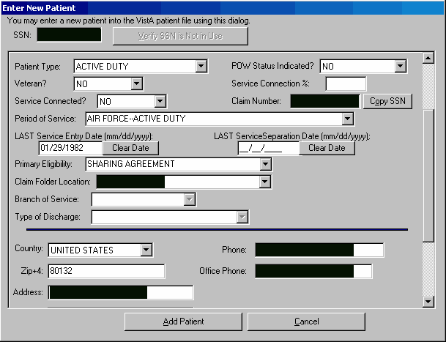

C&P Exam Detail Display for Active Duty Patient
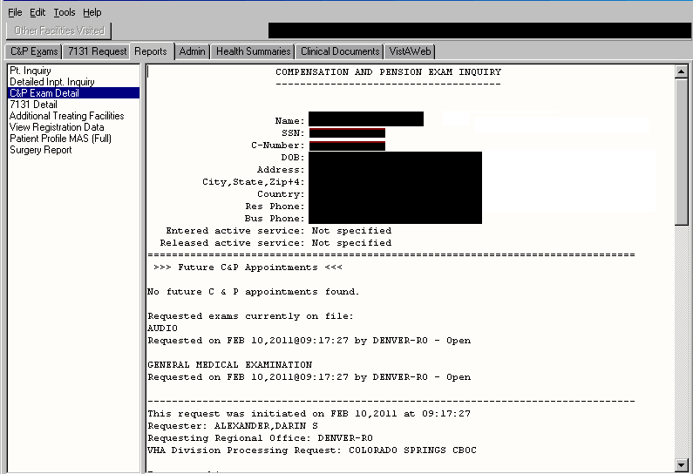

Enhancements
The following section is an overview of the VBA enhancements that have been added in this CAPRI GUI v149 and VistA patch (DVBA*2.7*149) release.

Enhancements with ClearQuest Tickets
The following Patch DVBA*2.7*149 VBA enhancements have been documented in the IBM® Rational® ClearQuest® change management tool.

CAPRI_CodeCR123:New Priority of Exam(s) Types
Issue
Modifications to CAPRI and the AMIE software are needed to allow selection of the following new PRIORITY OF EXAM codes when entering and/or editing a 2507 request:
- AO : AGENT ORANGE
- BDD : BEN DELIV AT DISCHG
(Benefits Delivery at Discharge)
- DCS : DES CLAIMED COND BY SVCMBR
(Claimed Condition by ServiceMember)
- DFD : DES FIT-FOR-DUTY
- QS : QUICK START
Solution
CAPRI and AMIE have been modified to allow selection of the following new PRIORITY OF EXAM codes when entering and/or editing a 2507 request:
- AO : AGENT ORANGE
- BDD : BEN DELIV AT DISCHG
(Benefits Delivery at Discharge)
- DCS : DES CLAIMED COND BY SVCMBR
(Disability Evaluation System Claimed Condition by Service Member)
- DFD : DES FIT-FOR-DUTY
- QS : QUICK START

CAPRI/AMIE - AMIS 290 Report Modifications:
Modifications have been made to CAPRI and the AMIE AMIS 290 Report software to support the new PRIORITY OF EXAM codes in the 2507 Request File (#396.3).
- CAPRI RPC: DVBAB AMIS REPORT
AMIS 290 and AMIS 290 by Division Reports
- AMIE Options: DVBA C AMIS REPORT
DVBA C RO AMIS 290

CAPRI/AMIE have been enhanced to:
- Allow the user to indicate the PRIORITY OF EXAM the report should be generated for
- AO : Agent Orange
- BDD : Benefits Delivery at Discharge and Quick Start
- DES : DES Claimed Condition by Service Member and Fit For Duty
- ALL : All Others (Original Report - minus new priorities)
- Modify the report to indicate the PRIORITY OF EXAM that it was generated for.
- Allow for a different calculation, 45 instead of 30, for the number of days exams are required to be completed in for the new PRIORITY OF EXAM codes:
- DCS (DES CLAIMED COND BY SRCMBR) and
- DFD (DES FIT-FOR-DUTY).
- Generate multiple reports for the NEW grouped PRIORITY OF EXAMS.
- BDD and QS
- DCS and DFD
- Make Regional Office selection optional. If no Regional Office is selected, then valid 2507 Requests will be retrieved for all Regional Offices.

CAPRI/AMIE - Insufficient Exam Reports (Detailed and Summary)

Modifications have been made to CAPRI and the AMIE software to support the new PRIORITY OF EXAM codes in the 2507 Request File (#396.3).

CAPRI/AMIE have been enhanced to:
- Allow the user to indicate the PRIORITY OF EXAM the report should be generated for.
- AO : Agent Orange
- BDD : Benefits Delivery at Discharge and Quick Start
- DES : DES Claimed Condition by Service Member and Fit For Duty
- ALL : All Others (Original Report - minus new priorities)
- Modify the report to indicate the PRIORITY OF EXAM that it was generated for.

AMIE VistA Options Affected by Addition of Priority of Exams with Patch DVBA*.27*149

OPTION | Testing Needed
AMIS 290 Report for C&P | Should be covered by testing for AMIS 290 requirements testing
AMIS 290 FOR THE REGIONAL OFFI | Should be covered by testing for AMIS 290 requirements testing
Check C&P File Integrity  (2 options – manual and TaskMan) | Lists POE for entries failing test
Edit C&P Request Information | Edit Static C&P Information presents POE as first editable data field
Enter a C&P Exam Request | First prompt is “2507 REQUEST PRIORITY OF EXAM”
Insufficient Exam Reports | Should be covered by Insufficient Exam testing
Manual Printing of New C&P Requests | POE is printed at bottom of page 1
Print New C&P Requests (Task Manager)
Manual Return of Transferred C&P Request | Request transferred must have POE at receiving site. Should have POE code, as the code was attached to the original request.
Transfer a C&P Request to Another Site | Code for POE is embedded in an e-mail message. Code must be present on receiving site.
Print C&P Final Report (Manual) | Appears on its own line, above “Examining Provider”.
Reprint C&P Final Report | Appears on its own line, above “Examining Provider”.
Transcribe C&P Data | Appears on its own line, above “Examining Provider”.

Non-AMIE VistA Options Affected by Addition of Priority of Exams with Patch DVBA*.27*149

Option | Testing Needed
HS Ad hoc report from CPRS | From VistA you need to go to the GMTS Manager menu, then the Health Summary Enhanced Menu. From here you can run an adhoc report and create a new HS type report. To test the change you will need to use the COMPENSATION AND PENSION EXAMS component in the adhoc report and in a HS type report.
HS Ad hoc report from VistA. | From VistA you need to go to the GMTS Manager menu, then the Health Summary Enhanced Menu. From here you can run an ad hoc report and create a new HS type report. To test the change you will need to use the COMPENSATION AND PENSION EXAMS component in the ad hoc report and in a HS type report.

CAPRI_CodeCR124:Make Fee Basis Community Nursing Home (FBCNH) Reports Available in CAPRI
Issue
Modifications to CAPRI were required to display the existing VistA Fee Basis Community Nursing Home Reports, to allow for more timely and efficient processing of hospital adjustments.
Solution
CAPRI has been enhanced to support the four (4) Fee Basis Community Nursing Home (FBCNH) Reports.
- FBCNH DISPLAY EPISODE OF CARE
- FBCNH ROSTER PRINT
- FBCNH REPORT OF ADMISSIONS/DISCHARGES FOR CNH
- FBCNH STAYS IN EXCESS OF 90 DAYS

All of the reports above can also be retrieved and saved by the CAPRI user in an '^' delimited format for use in external spreadsheet applications and/or databases except the FNBCH DISPLAY EPSIODE OF CARE Report. See the section on “Ability to Download Hospital Adjustment Reports into Excel/Access” below.

CAPRI_CodeCR126:Modify CAPRI to Allow Users to Select More Than One Outpatient Report to View When Using ‘Report Builder’
Issue
Modifications to CAPRI were required to enhance the Report Builder functionality to give users the ability to add multiple reports.
Solution
CAPRI Clinic document tabs have been enhanced by allowing the user the capability to select multiple report items, by selecting individual report items in the list or in multiples for addition into the Report Builder.

CAPRI_CodeCR127:Display the Date Range at the Top of the Special Report for Pension / Aid and Attendance
Issue
Modifications to CAPRI were required to display the data range at the top of the Special Report for Pension / Aid and Attendance.
Solution
CAPRI has been enhanced to display at the top of each page of the Special Report for Pension/A&A, the date range used in the creation of the report.

CAPRI_CodeCR129:Ability to Download Hospital Adjustment Reports into Excel/Access
Issue
Modifications to CAPRI were required to present multiple outputs options to users of the Hospital Adjustment Reports.
Solution
CAPRI has been enhanced to give users the ability to save the Hospital Adjustment Reports in an '^' delimited output for use in external spreadsheet applications and/or databases.

- Verify that plain text results in CAPRI v143 and CAPRI v149 look the same for each of the hospital adjustment reports.
Admission Report for SC Veterans
Start date: 4/11/2010 End date: 04/16/2010
CAPRI v143 results:
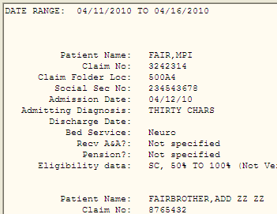
CAPRI v149 results:
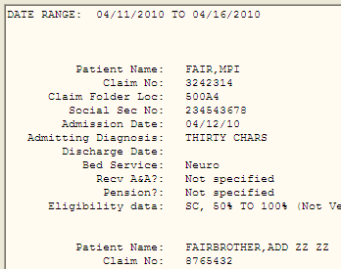

Admission Inquiry by Date
Start Date: 1/1/2009 End Date: 10/27/2010
CAPRI v143 results:
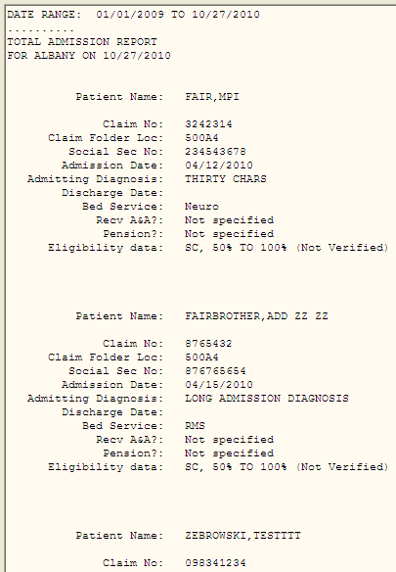

CAPRI v149 results:
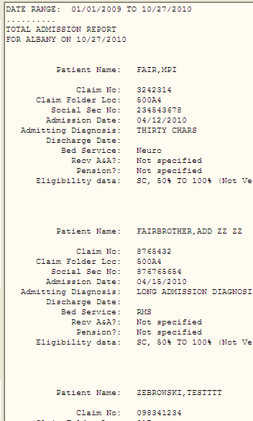

Special Report for A&A/Pension
Start Date: 12/1/2009 End Date: 10/27/2010
CAPRI v143 results:
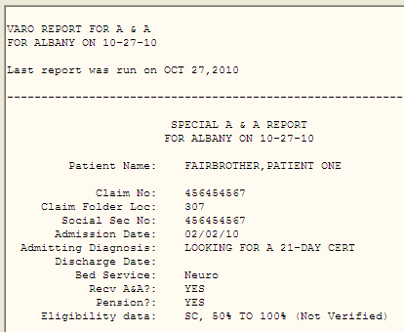

CAPRI v149 results:
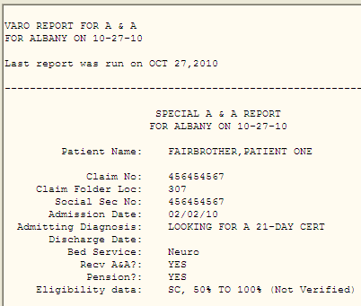

Re-Admission Report
Start Date: 3/5/1992 End Date: 3/20/1992
CAPRI v143 results:
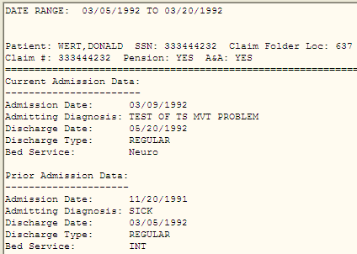

CAPRI v149 results:
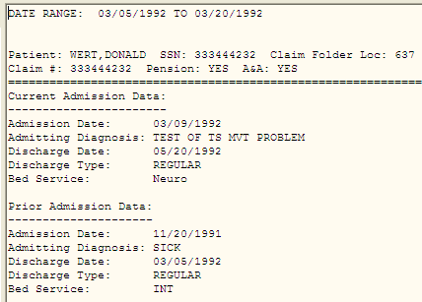

Discharge Report
Start Date: 3/20/2006 End Date: 5/15/2006
CAPRI v143 results:
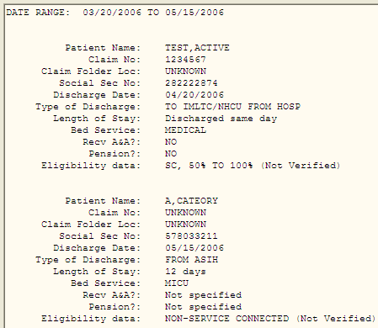
CAPRI v149 results:
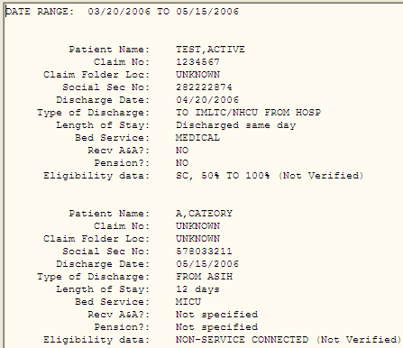

Incompetent Veterans Report
Start Date: 9/10/2007 End Date: 10/11/2007
CAPRI v143 results:
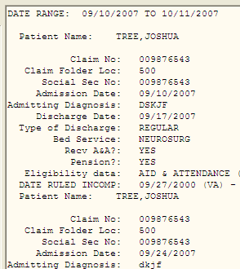

CAPRI v149 results:
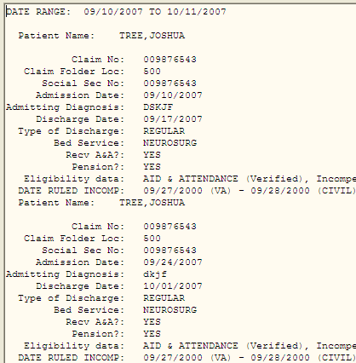

- Verify that delimited data is saved when results are present and the extract line count is displayed in the Reports memo box by re-running reports from step #1 and selecting Delimited Export Data.

Admission Report for SC Veterans
Start date: 4/11/2010 End date: 04/16/2010

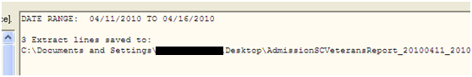

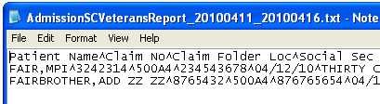
Admission Inquiry by Date
Start Date: 1/1/2009 End Date: 10/27/2010

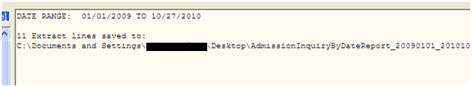

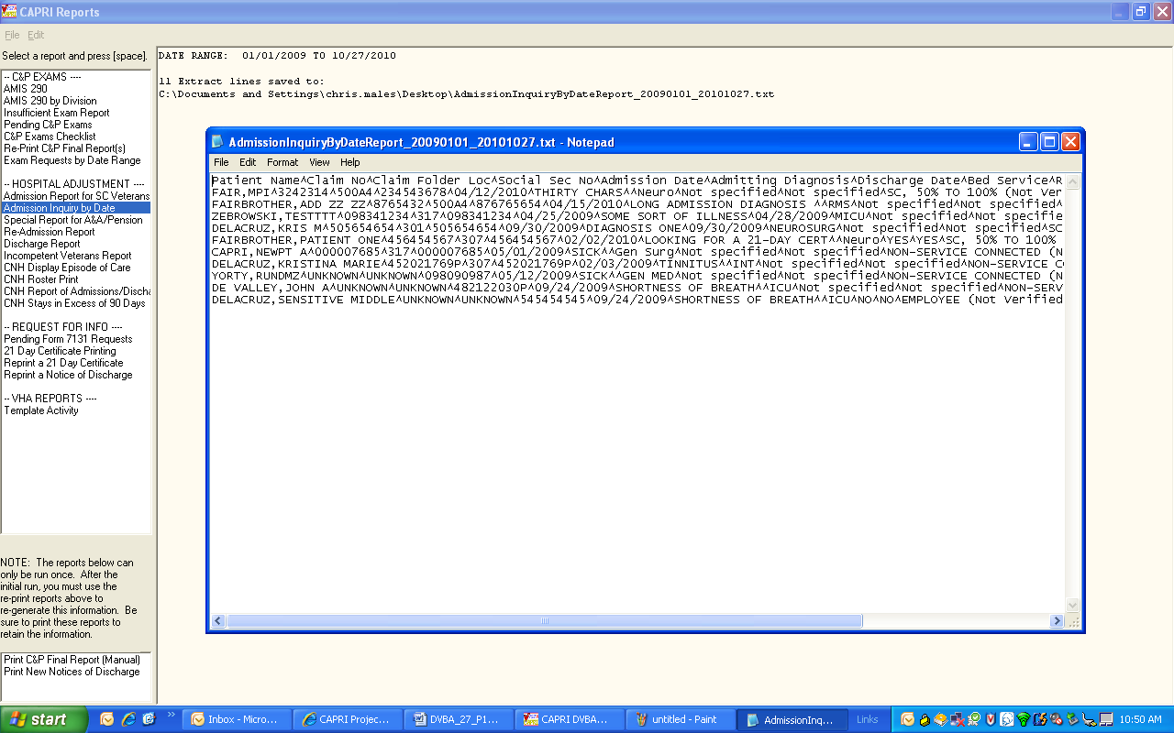

Special Report for A&A/Pension
Start Date: 12/1/2009 End Date: 10/27/2010

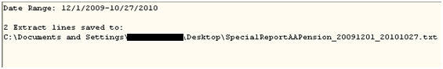

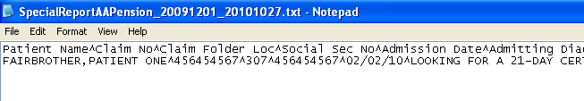

Re-Admission Report
Start Date: 3/5/1992 End Date: 3/20/1992

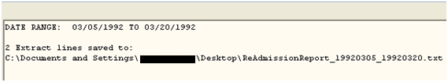

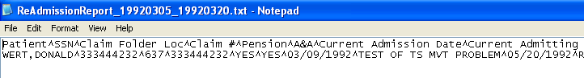

Discharge Report
Start Date: 3/20/2006 End Date: 5/15/2006

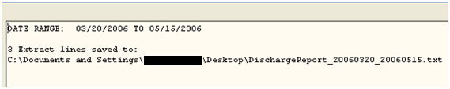

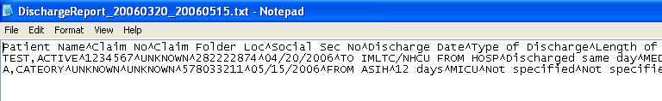

Incompetent Veterans Report
Start Date: 09/10/2007 End Date: 10/11/2007

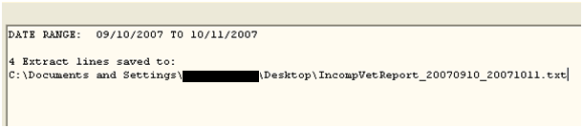

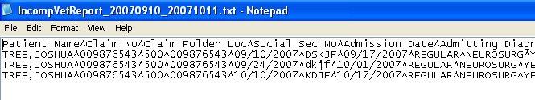

- Verify that the “Save As” warning dialog displays when attempting to use the name of an existing file for each of the Hospital Adjustment Reports and the Fee Basis reports. Test by running the same delimited report twice and attempting to save. See example below:
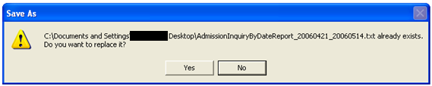
- Verify that the “No data found…” message displays and the save dialog does not display when no delimited text is returned.

Admission Report for SC Veterans
Start Date: 3/10/2010 End Date: 3/25/2010
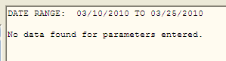

Admission Inquiry by Date
Start Date: 5/1/2010 End Date: 10/27/2010
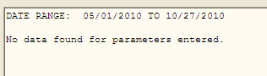

Special Report for A&A/Pension
Start Date: 2/5/2010 End Date: 10/27/2010
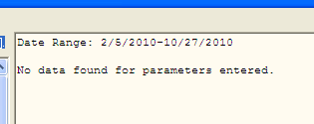

Re-Admission Report
Start Date: 3/21/1992 End Date: 3/25/1992
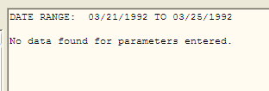

Discharge Report

Start Date: 4/21/2006 End Date: 5/14/2006

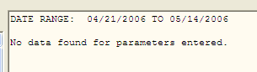

Incompetent Veterans Report

Start Date: 09/11/2007 End Date: 9/23/2007

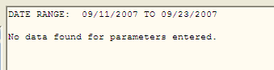

- Verify that each Fee Basis “Delimited Export Data” report (CNH Roster Print, CNH Report of Admissions/Discharges, and the CNH Stays in Excess of 90 day report ) displays the “Save As” dialog when results are present.

- Verify that the Fee Basis “Delimited Export Data” report is saved and the extract line count displayed in the Reports memo box is accurate.

CNH Roster Print

Input parameters: None
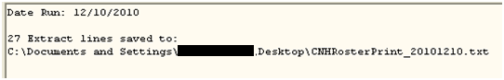

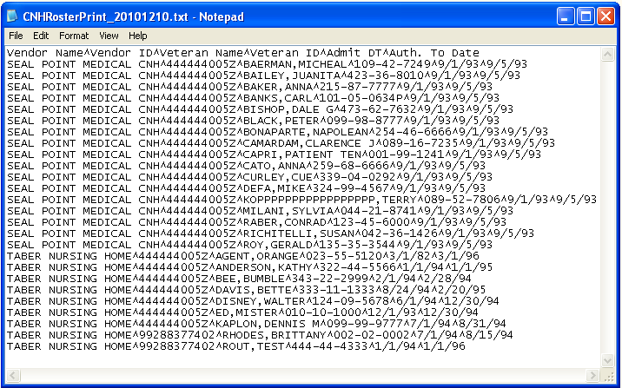

CNH Report of Admissions/Discharges

Start Date: 06/01/1994 End Date: 12/31/2010
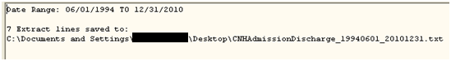

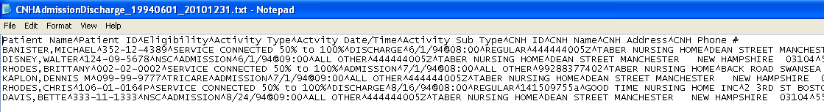

CNH Stays in Excess of 90 Days

Effective Date: 06/01/1994
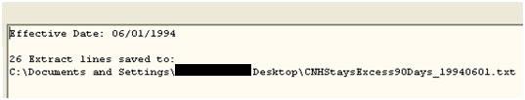

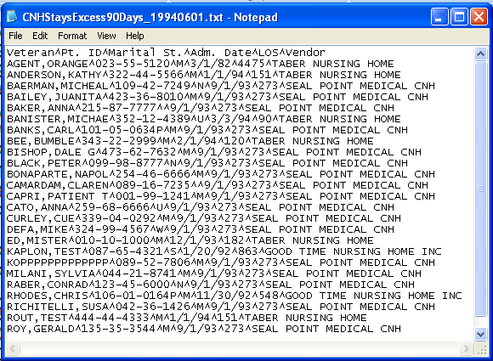

- Verify that each Fee Basis “Delimited Export Data” report displays the “No data found…” message and the save dialog does not display when no delimited text is returned for the selected report parameters.

CNH Roster Print

The remote procedure on the server side was modified to return “No data…” to satisfy this test case.

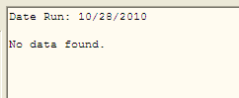

CNH Report of Admissions/Discharges

Start Date: 10/20/2010 End Date: 10/20/2010

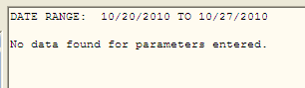

CNH Stays in Excess of 90 Days

Effective Date: 06/01/1980

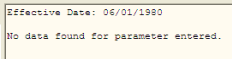

CAPRI_CodeCR130:Printing CAPRI Reports larger than 50 pages
Issue
Reports longer than 50 pages cause errors.
Solution
CARPI has been modified to allow printing to completion for reports longer than 50 pages.

CAPRI_CodeCR136:AMIE: Modify DVBA C ENTER C&P REQUEST to display foreign address
Issue
The AMIE option "Enter a C&P Exam Request" [DVBA C ENTER C&P Request] displays only USA address information when prompting the user to ensure they have the correct Veteran during the creation of a C&P Request. This option should display the correct address information, either USA or foreign, as applicable.
Solution
AMIE has been modified to either display USA address information or foreign address information when creating a C&P Request. In addition, users will also no longer have the ability to add a new Patient through this option [DVBA C ENTER C&P REQUEST].

CAPRI_CodeCR153:Remove Direct Appointment Global Reference
Issue
Upon review of routine DVBAB82, which was modified to support adding FEE BASIS functionality to CAPRI (RSD 2.6.4.), as well as other items, an invalid global reference was discovered during reviews. IA's for direct Appointment Global references to the PATIENT and HOSPITAL LOCATION Files have been rescinded, therefore these appointment global references need to be replaced with a call to Scheduling's supported API.
In addition, upon initial testing of the report (PATIENT PROFILE MAS) in CAPRI that is affected by removal of the direct appointment global references, it was noted that the user's responses to some of the prompts for displaying information were sometimes ignored when no results were available to display.
Solution
CAPRI has been modified so that the Patient Profile MAS report generated is based on the user’s selections. Currently if no data is available for a specific requested area, and the user did not make a selection for that area, the header and description that no values were found is still printed to the report. The report has now been modified to only display selections that were requested by the user.
CAPRI has also been modified to remove all direct appointment global references. Direct appointment global references have been replaced with a call to the supported Scheduling API, SDAPI^SDAMA301.

CAPRI_CodeCR158:Add New Cancellation Reason to 2507 CANCELLATION REASON File #396.5
Issue
When a C&P exam is requested, the C&P clinic only has a few drop-down menu options available to indicate that the Veteran will not be reporting for his/her exam. Currently, this list does not have an option for a veteran who does not want an examination appointment because he/she is electing to go the DBQ route. We need to add something to the drop-down list that accounts for this option.
Solution
Addition of a new cancellation reason, “VETERAN CANCELLED EXAM FOR DBQ”, in the 2507 CANCELLATION REASON File #396.5, which will allow selection of a more accurate descriptive reason by the user when the request/exam is cancelled.

CAPRI_CodeCR169: Enable the display of regional office substations in the Site List.
Issue
The Site List dialog that displays for selecting regional offices currently only displays station numbers that contain 3 digits. VBA is expanding the regional office designation to include suffixed station numbers.
Solution
The Site List dialog has been modified to not filter station numbers in the 300 and 400 number range that contain suffixes.

Customer – Health Revenue Center (HRC) Office

Defect Fixes
The following section is an overview of the defects reported by the HRC that have been addressed and corrected in the CAPRI GUI v149 and VistA patch (DVBA*2.7*149) release.

Defect Fixes with Remedy Tickets
The following Patch DVBA*2.7*149 VBA reported defects have been documented in the BMC Software Inc.® Remedy Action Request (AR) System® Change Management tool.

HD0000000433116:HRC Users getting only Toolbox Menu
Note: This issue is duplicated in Enhancement Request “CAPRI_CodeCR109: Modify CAPRI GUI to Recognize New Menus Added in Patch 148 as Primary Menus” described in Enhancements below in this section.

Defect Fixes with CearQuest Tickets
The following Patch DVBA*2.7*149 HRC reported defects have been documented in the IBM® Rational® ClearQuest® change management tool.

CAPRI_CodeCR104:Errors occur when user clicks more than once (double-click or more) on VistA button
Issue
When a user executes multiple clicks on the VistA button (C&P Exams tab), multiple errors can occur
Solution
CAPRI has been modified to pull the terminal window to the foreground, if already opened, instead of attempting to log onto VistA again when the VistA button is clicked.

Enhancements
The following section is an overview of the HRC enhancements that have been added in this CAPRI GUI v149 and VistA patch (DVBA*2.7*149) release.

Enhancements with ClearQuest Tickets
The following Patch DVBA*2.7*149 HRC enhancements have been documented in the IBM® Rational® ClearQuest® change management tool.

CAPRI_CodeCR109:HRC - Modify CAPRI GUI to Recognize New Menus Added in Patch 148 as Primary Menus
Issue
When a CAPRI HRC remote user is assigned one of the existing three HRC menus as their primary menu and connects to a site through CLAIMS, the HRC user is assigned the HRC menu as their primary menu. However, this is not the same case for CAPRI HRC remote users assigned to one of the new HRC menus. The CAPRI GUI application must be modified to recognize the new HRC Extended Services and HRC Pharmacy Customer Care menus and assign them as the user's primary menu at the remote site.
Solution
There were 2 modifications here. One is technical and the other is functional:
- The technical modification replaced the hard-coded list of HRC menu options in the CAPRI executable with database entries that could be modified in the future without a new GUI build.
- The functional modification added the 2 new HRC menus, DVBA HRC MENU EXTENDED SVCS and DVBA HRC MENU PHARMACY CC to the HRC menu list to allow them to be added as primary menus.

Customers – VBA and HRC

Defect Fixes
The following section is an overview of the defects reported by the VBA and HRC that have been addressed and corrected in the CAPRI GUI v149 and VistA patch (DVBA*2.7*149) release.

Defect Fixes with CearQuest Tickets
The following Patch DVBA*2.7*149 VBA and HRC reported defects have been documented in the IBM® Rational® ClearQuest® change management tool.

CAPRI_CodeCR77:143.10 CAPRI Remote Screen can no longer type site name with space and get to that site
Issue
When switching facilities within the CAPRI Remote window that contain a space, CAPRI doesn't recognize the space and next word in the name. Instead, CAPRI defaults to the first facility name in the list that contains the characters entered by the user. For example, if the user attempts to enter the facility "New York", CAPRI defaults to "NEW Jersey" since 'Jersey' precedes 'York' alphabetically in the facility list.
Solution
CAPRI has been modified to handle facility names that contain a space and default to the correct selection entered by the user.

Enhancements
The following section is an overview of the VBA and HRC enhancements that have been added in this CAPRI GUI v149 and VistA patch (DVBA*2.7*149) release.

Enhancements with ClearQuest Tickets
The following Patch DVBA*2.7*149 VBA and HRC enhancements have been documented in the IBM® Rational® ClearQuest® change management tool.

CAPRI_CodeCR:110 Display of VAMC Location City and State
Issue
CAPRI is being utilized by more new staff and even Non-VA users, and users are unfamiliar with the location of these sites listed.
Solution
CAPRI has been modified to include the city and state along with the name of the VAMC when displaying remote site selection lists. In addition, users will also be allowed to sort by state and site.

Customer – Health Information Access (HIA) Office

Enhancements
The following section is an overview of the HIA enhancements that have been added in this CAPRI GUI v149 and VistA patch (DVBA*2.7*149) release.

Enhancements with ClearQuest Tickets
The following Patch DVBA*2.7*149 HIA enhancements have been documented in the IBM® Rational® ClearQuest® change management tool.

CAPRI_CodeCR131:HIA – Automating DoD Access Limitations
Issue
Modifications to CAPRI to are needed to automate access limitations for DOD users to patients that have been seen at both the VA and DOD.
Solution
CAPRI has been enhanced to allow a user to be identified as a "DOD Only" user. If identified as a DOD Only user, only 'Active Duty' patients will be displayed. CAPRI has also been modified to initiate a call into the MPI Correlation API to validate whether a patient has been seen at both the VA and DOD. Patients are only presented to the user if they are listed in the MPI Correlation, else a message will display indicating otherwise.

Screenshot of Current Remote User Site Editor
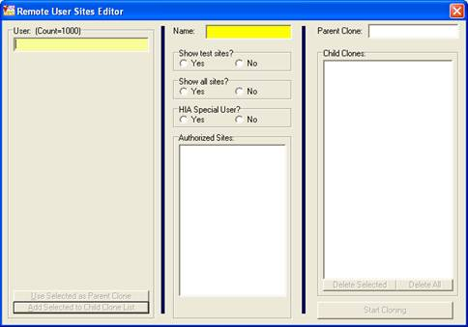

CAPRI_CodeCR161 – Modify HIA User Message Text for Patch Update
Issue
Modifications to CAPRI are needed to notify HIA users of the appropriate location for the CAPRI executable download when updating.
Solution
Modfied message text to display the following text as recommended by the HIA Team: 'You have been identified as a Health Information Access (HIA) user.'
'You will now be redirected to the HIA site to download the latest version of CAPRI.'

Enhancements That Did Not Require Source Code Changes

Removal of Simple Patient Entry Capability
Issue
In support of the Suicide Hotline staff CAPRI offers the capability to perform Simple Patient Entry. The Suicide Hot Line staff has built their own application and no longer needs the CAPRI application to support them with the Simple Patient Entry functionality that CAPRI provides.
Solution
CAPRI was originally designed for ease of maintainability and incorporates a security key mechanism that allows changes to the functionality offered to users without the need to make actual source code changes. By addition or removal of security keys to a user’s profile, the user can be denied or offered these configurable capabilities.
For this enhancement, no source code changes were required and rather the security key associated with Simple Patient Entry capability has been removed from all user profiles by the HIA staff.

Customer – Section 508 Compliance Office

Defect Fixes
The following section is an overview of the defects reported by the Section 508 Compliance Office that have been addressed and corrected in the CAPRI GUI v149 and VistA patch (DVBA*2.7*149) release.

Defect Fixes with CearQuest Tickets
The following Patch DVBA*2.7*149 Section 508 Compliance Office reported defects have been documented in the IBM® Rational® ClearQuest® change management tool.

508 Non-Compliance Issues
Issue
CAPRI has outstanding 508 Non-Compliance Issues.
Solution
CAPRI has been modified to address several outstanding 508 Non-Compliance Issues. Note: As part of these changes, the CAPRI GUI has been modified to default the “Last Rating Exam Date on the “Add New C&P Exam” on the C&P Exams tab to default to “N/A.” If the user chooses a date and decides to delete it they must click anywhere in the field and hit the “DELETE” key. They will then be prompted with “Do you wish to clear the last exam date?” with options for “Yes” and “No.” If “Yes” is chosen, then the field will be changed back to “N/A.” If they choose “No” it will remain populated with the date previously chosen.

Customer – All: General Modifications to CAPRI to Support all Customers

Enhancements
The following section is an overview of the enhancements available for all customers that have been added in this CAPRI GUI v149 and VistA patch (DVBA*2.7*149) release.

Enhancements with ClearQuest Tickets
The following Patch DVBA*2.7*149 enhancements available to all customers have been documented in the IBM® Rational® ClearQuest® change management tool.

CAPRI_CodeCR150:Add support for new Military Service Episode multiple field
Issue
Modifications to CAPRI/AMIE are needed to save/retrieve a Veteran's Military
Service Episode information to/from multiple locations based on the existence of the new MSE sub-file (.3216) in the PATIENT File #2 (To be exported in DG*5.3*797 at a later date).
Solution
CAPRI will, when creating a new patient, save the Veteran's last MSE information if applicable, to either the current [LAST] Service Fields or to the new sub-file MILITARY SERVICE EPISODE field #.3216 if it exists, in the PATIENT file #2. Also, AMIE/CAPRI will now always retrieve a Veteran's MSE information using the supported API, SVC^VADPT, which will return the Veteran’s last military episode information regardless of the data's location/source.

Known Anomalies
The following section describes the known anomalies within CAPRI GUI v149 and VistA patch DVBA*2.7*149. These anomalies will be fixed in the next CAPRI GUI and VistA patch.

CAPRI_CodeCR183: CAPRI 149 Military Service Episode Error

Issue:
When VBA users create new patients via CAPRI that do not contain values for Entry Date, Separation Date, Branch of Service, and Discharge Type, an error is displayed indicating “Military Service Episode Did Not File Successfully.”

Risk/Impact:
None/Low impact to users.

Workaround:
Even though the “Military Service Episode Did Not File Successfully” error message is displayed, any data entered by the user is still filed successfully.

Comments:
This will only affect VBA users who create a new patient via CAPRI that does not contain Entry Date, Separation Date, Branch of Service, and Discharge Type.

CAPRI GUI v149 Upgrade Note
Once the installation of patch DVBA*2.7*149 has been completed, CAPRI users should be upgraded to the new released version of the (CAPRI.exe [DVBA_27_149_11.ZIP]).

Please refer to the DVBA*2.7*149 patch description for specific instructions regarding the installation of the CAPRI GUI v149 software.

10.1. Backwards Compatibility Issue
For users remaining on versions of CAPRI prior to CAPRI GUI v143 (i.e. CAPRI GUI v140 and older), any Compensation & Pension Worksheet Module (CPWM) exam templates opened and saved using the new CAPRI GUI v149 will not be backwards compatible. Users of these older versions of the CAPRI GUI will experience errors when attempting to open CPWM exam templates saved using the new CAPRI GUI v149.

McAfee Host Intrusion Prevention (HIPS) Configuration
Some sites may experience problems with McAfee Host Intrusion Prevention (HIPS) configuration after installing CAPRI GUIv149.

10.2.1 Issue:

CAPRI may shut down or hang when users attempt to connect to the application. This may occur when either: the site selection list is presented during start-up and the user selects a site with a HIPS configuration that prevents access (for example, sites associated with the Black Hills system); or when the enterprise search function located on the patient selection screen toolbar is used to select a site as part of the search parameters.
10.2.2 Workaround:
Most users will not experience this issue. All instances of this issue should be reported to the
VA NSOC OPERATIONS (ePO) mailgroup for resolution of the HIPS configuration issue.

Software and Documentation Retrieval

VistA Patch DVBA*2.7*149
The VistA server software is being distributed as a PackMan patch message through the National Patch Module (NPM). The KIDS build for this patch is DVBA*2.7*149.

CAPRI GUI v149 Client Software & User Documentation
The CAPRI GUI v149 client software is being distributed as executable CAPRI.exe contained in the zip file [DVBA_27_P149_11.ZIP]).
The CAPRI GUI v149 client software and documentation for this patch may be retrieved directly using FTP. The preferred method is to FTP the files from:
download.vista.med.va.gov
This transmits the files from the first available FTP server.
Sites may also elect to retrieve software directly from a specific server as follows:
OI&T Field Office | FTP Address | Directory
Albany | ftp.fo-albany.med.va.gov | [anonymous.software]
Hines | ftp.fo-hines.med.va.gov | [anonymous.software]
Salt Lake City | ftp.fo-slc.med.va.gov | [anonymous.software]

File Name | Format | Description
DVBA_27_P149_11.ZIP | Binary | ZIP archive containing the CAPRI GUI v149 Client Application executable: CAPRI.exe
DVBA_27_P149_UM.PDF | Binary | Updated CAPRI User Manual
DVBA_27_P149_RN.PDF | Binary | Release Notes (This document).

The VistA Documentation Library (VDL) web site will also contain the updated CAPRI User Manual. This web site is usually updated within 1-3 days of the patch release date.
The VDL web address for CAPRI documentation is: http://www.va.gov/vdl/application.asp?appid=133

